**Assignment 2: Design An IOT Egg Incubator**

‭Deepanshi‬ ‭456807‬

**‭Bow Valley College‬**

TECH1102:Internet of Things

‭Instructor: Dima Marachi

‭March 21, 2024.‬

Ques 1) Paste the picture of the block diagram.

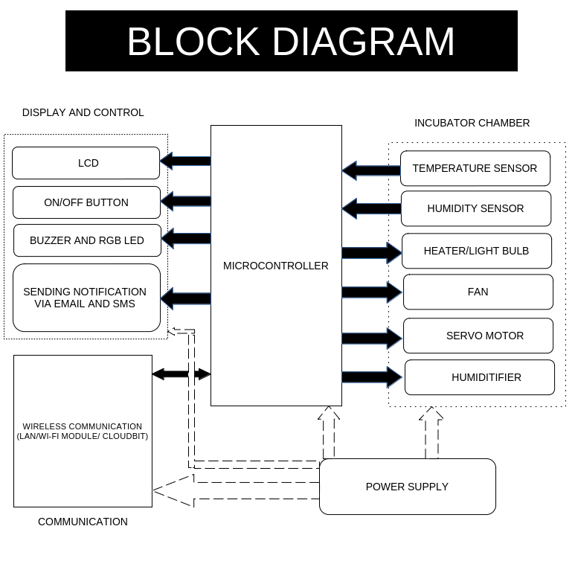

Ques 2) Please paste in your spell-checked and grammar-checked design summary.

Ans:

This is an Ardunio-controlled incubator for chicken eggs. The aim is to create artificial incubators that keep the record at different temperatures and humidity so that at the defined value the eggs are incubated and the chicks finally hatch from the egg.

**Components:**

1. **Power supply:** The system's power supply is a 12 V stabilized power supply that receives a 220 V input voltage and sends 12 V and 5 V DC voltage and a 30 A current to its outputs. Even though a 220 V power supply is presented here, the system is operated at a maximum of 12 V.
2. **Heater/ Light Bulb:** A 25-watt bulb is a heat source; higher wattage may hurt the eggs in a small container. Light bulbs/heaters are used to regulate the temperature inside the incubator. Maintaining a consistent and optimal temperature is crucial for the development of embryos within the eggs. Light bulbs/heaters provide the necessary warmth to simulate the natural conditions for egg incubation.
3. **DHT11 Sensor:** It senses temperature and humidity and gives digital values corresponding to both temperature and humidity
4. **Humidifier(designed to increase humidity levels in a room):** When water passes over it, the water is transformed into a mist made of extremely ﬁne droplets. The performance of the equipment depends highly on the moisture content during the incubation and hatching phase. Therefore the humidity level in the incubation chamber is accurately controlled through the humidiﬁer.
5. **Fan:** The fan does not need to be controlled, it is constantly running and distributes heat and humidity equally in the incubator. The Arduino monitors the fan using its rpm signal and sets an alarm if it fails. The fan also cools the heating wire, the heating is turned off if the fan fails.
6. **Servo Motor:** A servo motor can be connected to a mechanism that holds the eggs and rotates them at predetermined intervals. The servo motor's precise control allows for accurate positioning and timing of the egg-turning process.

**Display and control:**

1. The electronic control module based on the Arduino Mega 2560 board is the main controller. It controls all the other modules of the system. LCD is used to display the current temperature.
2. The keyboard allows the input of the incubation parameters for the operation of the system. This module allows the user to communicate with the device by setting up the following: On/Off: to turn on the equipment and its operation indicator; Set the incubation temperature, humidity, number of turns, and number of days of incubation; Restart the device; Manually turn over the eggs, change temperature and humidity.

Here's a step-by-step procedure outlining how the Arduino-controlled incubator works for hatching chicken eggs:

1. **Power On**: The user switches on the incubator, supplying power to all components via the 12V stabilized power supply.
2. **Initialization**: The Arduino Mega 2560 board initializes and begins running the incubator program.
3. **Sensor Readings**: The DHT11 sensor starts taking readings of temperature and humidity inside the incubator at regular intervals.
4. **Display Information**: The Arduino processes the sensor readings and sends the current temperature data to the LCD for the user to see.
5. **User Input**: The user interacts with the keyboard to input the desired incubation parameters, including:
   * Set the target temperature and humidity levels.
   * Specify the number of egg turns per day.
   * Define the duration of the incubation period.
6. **Control Algorithm**:
   * **Temperature Control**: The Arduino compares the current temperature reading from the DHT11 sensor with the user-defined target temperature. If the temperature is too low, the Arduino activates the heater/light bulb to increase the temperature. If it's too high, it turns off the heater/light bulb.
   * **Humidity Control**: Similarly, the Arduino compares the current humidity reading with the user-defined target humidity. If the humidity is too low, the Arduino activates the humidifier to increase humidity. If it's too high, it turns off the humidifier.
7. **Fan Operation**:
   * The fan runs continuously to ensure uniform distribution of heat and humidity inside the incubator.
   * The Arduino monitors the fan's operation and triggers an alarm if it fails.
8. **Egg Turning**:
   * The Arduino controls the servo motor to rotate the eggs at predetermined intervals. This prevents the embryos from sticking to the shell membrane and promotes uniform development.
   * The servo motor's operation is synchronized with the incubation period and the user-defined number of egg turns per day.
9. **Monitoring and Feedback**:
   * Throughout the incubation process, the Arduino continuously monitors temperature, humidity, fan operation, and egg turning.
   * If any parameter deviates from the desired range or if there's a system malfunction (e.g., fan failure), the Arduino triggers an alarm to alert the user.
10. **Hatching**: After the specified duration of the incubation period, the eggs reach the hatching stage. The user can manually observe the hatching process through the transparent walls of the incubator.
11. **Completion**: Once the incubation period is complete and the chicks have hatched, the user can power off the incubator and remove the chicks for further care.

Ques 3) Please list three alternative network communication methods you considered for the Arduino, and indicate why you selected the one in your design. Be specific!

Ans:

1. **WI-FI modules using ESP8266:** The NodeMcu ESP8266 is a module that lets your microcontroller connect to Wi-Fi networks and establish basic TCP/IP connections using simple commands. It comes with built-in Wi-Fi features, making it easy to program and allowing communication with web servers, cloud platforms, or other devices over Wi-Fi networks. Essentially, it's like giving your microcontroller the ability to join Wi-Fi networks and talk to other devices on the internet using straightforward commands.
2. **LAN:** It stands for Local Area Network. It refers to a network that connects computers, devices, and resources within a limited geographical area, such as a home, office, or school campus. We utilize a LAN connection directly with a computer to link the Arduino incubator and computer, allowing us to be informed as well as monitor such as temperature, humidity, and other parameters from our computer or smartphone via a LAN connection to a network.
3. **CloudBit:** The cloudBit is the easiest way to create internet­-connected devices. We can now snap the internet to anything! Retrofit your temperature, humidity, and other parameters from anywhere in the world using a smartphone, tablet, or computer. No programming, soldering, or wiring is required.

Ques 4) Please list three alternative data logging strategies you considered for the incubator and indicate why you selected the one in your design. Be specific!

Ans:

1. **Memory Card(eg, SD card):** For data logging in your egg incubator offers several advantages. Firstly, memory cards provide **non-volatile storage**, meaning data is retained even when the power is turned off, ensuring the secure preservation of your incubator's environmental data, even during power outages. Secondly, memory cards typically offer **ample storage capacity**, allowing you to log a large amount of data over an extended period, which is beneficial for maintaining detailed records for analysis and troubleshooting. Additionally, memory cards are **easily accessible**; they can be removed from the incubator and inserted into a computer or other device for data retrieval and analysis
2. **Cloud-based data-logging:** It offers a robust solution for maintaining a permanent record of your incubator's environment. By transmitting data from the incubator to a remote server or cloud platform for storage, this method ensures that even if the power to the incubator is lost, the data remains securely stored in the cloud.

This remote storage capability allows for easy access to the data from anywhere with an internet connection, facilitating remote monitoring and analysis. Moreover, cloud platforms typically incorporate advanced security measures to safeguard stored data against loss or unauthorized access.

1. **ROM memory(eg: EEPROM):** EEPROM is commonly used in microcontrollers like Arduino for storing small amounts of data that need to be retained even when power is removed. It is somehow similar to an SD Memory Card, the same non-volatile memory that can store data even if the power is removed, but there is little difference between a memory card and an Electrically Erasable Programmable Read-Only Memory. EEPROM is typically integrated directly into the microcontroller or embedded system. It is a small, dedicated area of memory within the microcontroller itself, whereas, Memory cards are external storage devices that can be connected to a microcontroller or computer.
2. **Battery-back System:** Including a battery backup system in an incubator project is crucial. It guarantees that our data logging tools keep running smoothly even if there's a power outage. This ensures we don't miss any important information about the environment inside the incubator. With this system in place, we can trust that our records remain accurate and complete, no matter what happens with the power supply. Plus, it makes maintenance much easier, boosting the overall reliability of the incubation process and helping ensure its success.

Ques 5) Please list two alternative notification strategies you considered for your incubator and indicate why you selected the one in your design. Be specific!

Ans:

**For local notifications:**

Two alternative warning methods are a buzzer and an RGB LED

1. The **buzzer** can be used to notify the user when an egg has emerged or to convey danger or caution in the event of major temperature fluctuations during incubation.
2. An **RGB LED** could be used to change color to notify the user when an egg hatches, as well as to indicate failure.

* Bright **red LED** for the indication when the incubator is too hot or when a mistake has occurred.
* Egg hatching may be indicated by a **green LED.**
* When it is too cold inside the incubator, the **blue LED** isturned on to show that maybe the incubator temperature is too low.

1. Sending notifications via email or SMS messages to the user's mobile device or computer. (Another Method) When the device is connected with smartphones, tablets, or computers through CloudBit, LAN, or WI-FI module.

**REFERENCES**

1. Kuriakose A. (n.d.). Incubator**,** from<https://github.com/aln0071/Incubator>
2. Quantenschaum. April 03, 2018. ProjectHub, from <https://projecthub.arduino.cc/quantenschaum/egg-incubator-e47cd6>
3. Swagatam. Incubator Using Arduino with Automatic Temperature and Humidity Control. Retrieved on January 3, 2024, from <https://www.homemade-circuits.com/incubator-using-arduino-with-automatic-temperature-and-humidity-control/>
4. Kapen P, Mohamadou Y, Momo F, Manfouo H. November 2020. Design and prototyping of a low-cost, energy-efficient eggs incubator in developing countries: A case study of Cameroon, from <https://www.researchgate.net/publication/345763026_Design_and_prototyping_of_a_low-cost_energy_efficient_eggs_incubator_in_developing_countries_A_case_study_of_Cameroon>
5. R. Rakhmawati, Irianto, F. D. Murdianto, A. Luthfi, and A. Y. Rahman, "Thermal Optimization on Incubator using Fuzzy Inference System based IoT," 2019 International Conference of Artificial Intelligence and Information Technology, from<https://ieeexplore.ieee.org/document/8834530>
6. littleBits cloudBit Module. (n.d). Adafruit, from <https://www.adafruit.com/product/2330>
7. Edin Mujčić and Una Drakulić 2021 IOP Conf. Ser.: Mater. Sci. Eng. 1208 012038, from <https://iopscience.iop.org/article/10.1088/1757-899X/1208/1/012038/pdf>
8. Vilaswkhade. June 19, 2020. IoT - Eggs Incubator. Hackster.io, from <https://www.hackster.io/vilaswkhade/iot-eggs-incubator-d6188b>
9. Maroma, Allen N.; Maroma, Dolly P.; and Pangilinan, Bernardo A. (2023). Development of Automated Egg Incubator With Backup Power Supply. ASEAN Journal of Community Engagement, 7(2), 151-164. from <https://scholarhub.ui.ac.id/cgi/viewcontent.cgi?article=1222&context=ajce>
10. Yudhi Gunardi, Agus Setyabudi Department of Electrical Engineering, Universitas Mercu Buana. Published on: 03-12-2019. Design of Monitoring of Egg Incubator Machine Based on the Internet of Things with ESP8266 and Web Server, from <https://ijeeet.com/index.php/ijeeet/article/view/27>